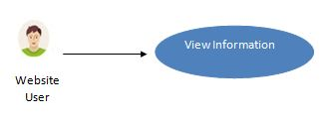

#### Figure 3.2 View Information (website)

Website user can view the every information which is provided by the pet hospital like services etc.

|  |  |
| --- | --- |
| Name | View Information(website) |
| Actor | Website user |
| Brief Description | Website user is able to view the every information which is mentioned on the website. |
| Flow of Events | User can view hospital services, about us and doctors detail etc or any further information provided by the hospital. |
| Alternate Flow of  Events | User will take an appointment. |
| Pre-condition | Should click on any button in the menu bar or scroll down the cursor. |
| Post condition | User might take a decision of appointment. |

##### Table 3.1: View Information (website)

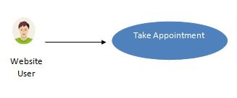

#### Figure 3.3 Appointment (website)

Website user can take the appointment.

|  |  |
| --- | --- |
| Name | Appointment(website) |
| Actor | Website user |
| Brief Description | Website user is able to take an appointment. |
| Flow of Events | User will fill all the inputs text fields required for taking an appointment. Like enter mobile number, pet name, date and times etc. |
| Alternate Flow of  Events | User will view the information. |
| Pre-condition | Fill all the input text fields. |
| Post condition | Response email will be send to the user. |

##### Table 3.2: Appointment (website)

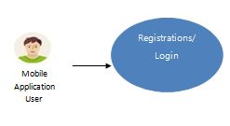

#### Figure 3.4 Registrations/ Login

First of all Android Application User will register himself by filling registration form in order to login into the system or perform other activities.

|  |  |
| --- | --- |
| Name | Registration/ Login |
| Actor | Android Application User |
| Brief Description | Registration is compulsory for the first time to login. |
| Flow of Events | Fill all the input text fields. Provided information will be verified then user will be register.  If user is already register then there is no need of performing registration. Registration is compulsory for the first time to login. |
| Alternate Flow of  Events | If validation fails, then user can resend it. |
| Pre-condition | All fields of registration and login are essential. |
| Post condition | User will login into the system and perform other activities. |

##### Table 3.3: Registration/Login

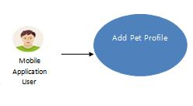

#### Figure 3.5 Add Pet Profile

Android Application User can add pet profile details upon successful login.

|  |  |
| --- | --- |
| Name | Add Pet Profile |
| Actor | Android Application User |
| Brief Description | User is able to add the pet profiles. |
| Flow of Events | Fill the all input text fields necessary for the pet profile then added profiles are saved into the database. |
| Alternate Flow of  Events | If fields are missing then user can refill them. |
| Pre-condition | Some information is necessary |
| Post condition | Added information can be viewed. |

##### Table 3.4: Add Pet Profile

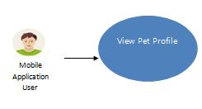

#### Figure 3.6 View Pet Profile

Android Application User can also view the pet profile.

|  |  |
| --- | --- |
| Name | View Pet Profile |
| Actor | Android Application User |
| Brief Description | User is able to view the pet profile fetched from the databases. |
| Flow of Events | After clicking the view profile button user is able to view the pet profile. |
| Alternate Flow of  Events | If click on any other button. |
| Pre-condition | If view profile button is clicked. |
| Post condition | Viewed information is fetched from database. |

##### Table 3.5: View Pet Profile

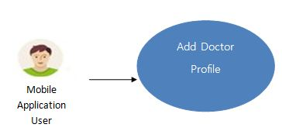

#### Figure 3.7 Add Doctor Profile

Android Application Admin can be a add doctor. if and only if the entered hospital id matches with the assigned hospital id.

|  |  |
| --- | --- |
| Name | Add Doctor |
| Actor | Android Application User |
| Brief Description | User is able to add himself as a doctor if and only if the hospital id matches. |
| Flow of Events | Fill the all input text fields necessary for the profile then added profiles are saved into the database. |
| Alternate Flow of  Events | If fields are missing then user can refill them. |
| Pre-condition | Some information is necessary |
| Post condition | Added information can be viewed. |

##### Table 3.6: Add Doctor Profile

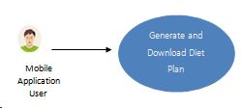

#### Figure 3.8 Generate and Download Diet Plan

Android Application User can also generate and download the pet diet plan. Diet plans are generated on the basis of pet specie, breed (weekly or daily), age and type of plan.

|  |  |
| --- | --- |
| Name | View / Download Diet Plan |
| Actor | Android Application User |
| Brief Description | User is able to view and download the pet diet plan. |
| Flow of Events | Select the pet specie, breed, age and type of plan (weekly or daily) then click on generate plan button then diet plan will be generated from the database. |
| Alternate Flow of  Events | If any filed is missing then no plan will be shown and downloaded. |
| Pre-condition | If generate or download diet plan button is clicked. |
| Post condition | Information is fetched from database. |

##### Table 3.7: Generate and Download Diet Plan

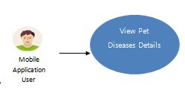

#### Figure 3.9 View Pet Diseases Details

Android Application User can also view the common diseases details.

|  |  |
| --- | --- |
| Name | View Pet Diseases Details |
| Actor | Android Application User |
| Brief Description | User is able to view the common diseases details fetched from the databases. |
| Flow of Events | Select the pet specie.  Then after clicking the view button user is able to view the common diseases details. |
| Alternate Flow of  Events | If click on any other button. |
| Pre-condition | If pet diseases detail button is clicked. |
| Post condition | Information is fetched from database. |

##### Table 3.8: View Pet Diseases Details

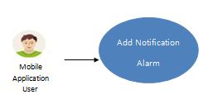

#### Figure 3.10 Add Notification Alarm

Application User can add notification alarm for the multiple pets.

|  |  |
| --- | --- |
| Name | Add Notification Alarm |
| Actor | Android Application User |
| Brief Description | User is able to add the notification alarm related to pet food timings for the multiple pets. |
| Flow of Events | Set the alarm time and then enter the pet name. Then click on set alarm button.  Alarm will be set down. |
| Alternate Flow of  Events | User can delete any list item. |
| Pre-condition | Pet name, time and click on set alarm button are necessary. |
| Post condition | Alarm can be deleted. |

##### Table 3.9: Add Notification Alarm

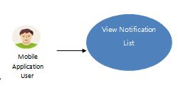

#### Figure 3.11 View Notification List

Application User can also view the all information available on application related to notifications of pet food timings.

|  |  |
| --- | --- |
| Name | View Notification List |
| Actor | Android Application User |
| Brief Description | User is able to view the notification list related to pet food timings. |
| Flow of Events | Click on Alarm list then user will be able to view the notification alarm list. |
| Alternate Flow of  Events | User can delete any list item.  User can turn off the alarm. |
| Pre-condition | Click on alarm list button is necessary. |
| Post condition | Viewed information can be deleted. |

##### Table 3.10: View Notification List

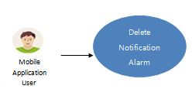

#### Figure 3.12 Delete Notification Alarm

Application User can delete the notification list items one by one.

|  |  |
| --- | --- |
| Name | Delete Notification Alarm |
| Actor | Android Application User |
| Brief Description | User is able to delete the any notification list item related to pet food timings. |
| Flow of Events | Click on Alarm list then click on cross sign; a dialog box will be opened if yes is clicked then alarm will be deleted... |
| Alternate Flow of  Events | User can turn off any alarm. |
| Pre-condition | If yes in clicked. |
| Post condition | Can perform on other activities or add a new alarm. |

##### Table 3.11: Delete Notification Alarm

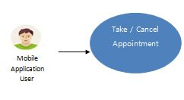

#### Figure 3.13 Take / Cancel Appointment

Android Application user is able to take an appointment or cancel it.

|  |  |
| --- | --- |
| Name | Take / Cancel Appointment |
| Actor | Android Application User |
| Brief Description | Emails will send for the both cases if appointment is taken or cancelled. |
| Flow of Events | If appointment button is clicked then appointment email will be send.  If cancel button is clicked then cancel the appointment message is send. |
| Alternate Flow of  Events | User can view the doctors’ information. |
| Pre-condition | If appoint or cancel button in clicked. |
| Post condition | Can perform other activities within the application... |

##### Table 3.12: Take / Cancel Appointment

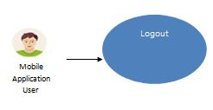

#### Figure 3.14 Logout

Application User is able to logout at any time.

|  |  |
| --- | --- |
| Name | Logout |
| Actor | Android Application User |
| Brief Description | After successful login Application User is able to logout at any time. |
| Flow of Events | Click on logout button then user will be logout from the application. |
| Alternate Flow of  Events | Shut down the system. |
| Pre-condition | All activates are completed no more need to stay log in. |
| Post condition | User is able to re login into the system at any time. |

##### Table 3.13: Logout Details Specification